AUTONOMOUS BATTLE DAMAGE ASSESSMENT

DESIGN
(v1.0-FINAL)

DOCUMENT HISTORY

DATE | STATUS | VER | AUTHOR | NOTES
20260121 | Draft | 0.1 | Cory Wingate | Create initial draft
20260202 | Draft | 0.2 | Iggy Siegel | Add custom evaluation metric; distinct modeling phases
20260206 | Final | 1.0 | Iggy Siegel | Standardized formatting, final draft

1.0 INTRODUCTION

Battle Damage Assessment (BDA) is a critical component of Army targeting operations, enabling commanders to determine whether an engagement achieved its intended effects or requires re-attack. Despite its importance, current BDA processes rely heavily on manual imagery review and narrative reporting, which introduces delays, inconsistency, and risk to Soldiers operating in contested environments. As modern operations generate increasing volumes of imagery from drones and autonomous platforms, these limitations reduce operational tempo and strain limited analyst resources.

To address this problem, this project adopts a modular design intended to evaluate whether automated BDA generation is feasible in research environments. The design emphasizes portability, offline execution, and objective performance evaluation using open-source data. Key design decisions focus on separating experimental model development from deployment packaging, supporting standardized outputs aligned with doctrine, and enabling controlled comparison of alternative model architectures. The remainder of this document details the assumptions, architecture, data design, implementation flow, and testing strategy that guide these decisions.

2.0 DESIGN CONSIDERATIONS

The primary design assumptions center on data availability and validation of model performance. Given that no pre-existing dataset was provided, the system relies on manually curated open-source imagery to represent post-strike conditions. These images are assumed to reflect the types of damage typically seen in a BDA, while acknowledging that such imagery lacks the background context of a military mission, such as mission intent. Consequently, evaluation criteria are strictly limited to physical damage. Ground truth labels are derived from analyst judgment informed by doctrinal definitions, with the assumption that a curated set of 250 to 1000 labels provides a sufficient baseline for performance evaluation. Final testing will occur in a simulated environment at DEVCOM Army Research Lab (ARL).

As discussed in the requirements document, hardware constraints further dictate the system’s scope. Development is restricted to a local environment with 16GB VRAM, while the final deployment environment must be compatible with edge devices capped at 64GB VRAM. This hardware ceiling, combined with the necessity for performance in degraded environments, ensures that cloud-based inference is neither required nor supported.

The system is designed for local, offline execution on Linux-based machines. This environment is critical for ensuring reproducibility and aligning with the deployment realities of tactical settings where networking may be unavailable. To manage this, the design follows a modular methodology that decouples the experimental modeling phase from the deployment packaging.

This modularity allows for the experimentation of various architectures and ensures the system can ingest future open source, state-of-the-art models from platforms like Hugging Face or Ollama. For the final deployment, the system utilizes a containerized approach to ensure that the software stack remains portable and ready for execution on local edge devices without further configuration.

3.0 SYSTEM ARCHITECTURE / DESIGN OVERVIEW

3.1 The system architecture is divided into two distinct parts: a deployment environment focused on operational BDA generation and an experimental environment for model development and benchmarking.

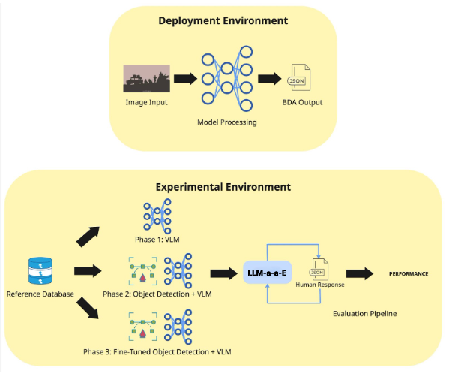
Figure 1: Design Architecture Diagram

3.2 The deployment architecture is designed to be minimal and robust, supporting execution in a constrained environment. It focuses exclusively on transforming imagery into structured BDA outputs without external dependencies. The deployment system consists of the following components:

3.2.1 Image Input: Imagery is assumed to be captured by an edge device. For the purposes of this project, image capture consists of an input directory containing post-strike images.

3.2.2 Model Processing: A multi-modal machine learning engine that executes a model using conditional, doctrinally-informed prompts based on the types of objects present in the strike scene. The model performs target element identification, physical damage assessment at the target element level, and functional damage assessment at the scene level.

3.2.3 BDA Output: The system produces a structured JSON BDA product for each processed image, formatted according to doctrine for seamless integration into existing analyst workflows.

3.3 The project also includes an experimental environment to facilitate controlled research and quantitative comparison of model variants. This portion of the architecture exists solely within the research repository and is not intended for operational deployment. The experimental environment consists of the following components:

3.3.1 Reference Dataset: A dataset of post-strike imagery alongside analyst reviews. These human assessments serve as doctrinally informed reference labels for evaluation.

3.3.2 Model Variant Pipeline: A modular framework to test increasing architectural complexity. The baseline is a standalone VLM. In the next phase, it is assumed adding an object detector to the VLM will better inform doctrinal prompt selection and therefore increase performance. The final phase fine tunes the object detection model with an open source military assets dataset.

3.3.3 Evaluation Pipeline: An automated script that leverages an LLM evaluator. This evaluator compares model outputs against the image’s analyst-provided reference label using a custom metric, aggregating performance across all model variants.

4.0 DATA DESIGN

4.1 The dataset is composed of post-strike images and associated reference labels generated by human analysts. Each reference label is stored as a JSON object, mapped to doctrinal definitions. Reference labels are decomposed into three primary layers:

4.1.1 Target Classification: Identifies each target type in an image across 21 distinct categories (e.g., Bridges, Buildings, Ground Force Personnel).

4.1.2 Physical Damage Assessment: For every target in a scene, it identifies the physical damage category (three to five categories based on target type, e.g., No Damage, Damaged, Destroyed, Unknown) and confidence level (Confirmed, Probable, Possible).

4.1.3 Functional Damage Assessment: A seven-tier scale assessing operational capability for the scene as a whole, ranging from No Functional Damage to Functionally Destroyed.

To support downstream evaluation, the reference labels are structured as follows:

{
“metadata”: {
“image_id”: “target_001.jpg”,
“datetimegroup”: “DDHHMMZMONYY”,
“location”: “XXX XX 0000 0000”,
“report_type”: “BDA”,
“analyst”: “bda_svc”,
},
“physical_damage”: {
“target_1”: {
“target_type”: “bridge”,
“damage_category”: “severe damage”,
“confidence_level”: “confirmed”,
“logic”: “supporting evidence…”
},
…
“target_n”: {
“target_type”: “ground force personnel military units”,
“damage_category”: “attrited”,
“confidence_level”: “probable”,
“logic”: “supporting evidence…”
},
},
“functional_damage”: {
“assessment”: “severe functional damage”,
“logic”: “supporting evidence…”
},
}
Figure 2: Example Reference Label

5.0 IMPLEMENTATION OVERVIEW

5.1 The system’s operational logic follows a linear pipeline, transforming raw sensor data into structured intelligence through the following stages:

5.1.1 Data Ingestion: The system ingests imagery captured by the edge device’s optical sensors from a designated local directory.

5.1.2 Target Detection and Classification: The image is passed to the primary model (or detection sub-module) to localize and classify target elements (e.g., identifying three “Ground Force” targets).

5.1.3 Doctrinal Logic Injection: Based on the identified target categories, the system dynamically retrieves and injects target-specific doctrinal definitions into the model prompt. This ensures the model evaluates damage according to specific military standards for that asset class.

5.1.4 Multi-Modal Inference: The VLM processes the image and the conditional prompt to perform two parallel analyses: per-target physical damage category and confidence level, and overall scene functional damage assessment.

5.1.5 Report Formatting: The raw model inference is parsed into a structured JSON report, which is then exported to the local output directory for analyst review.

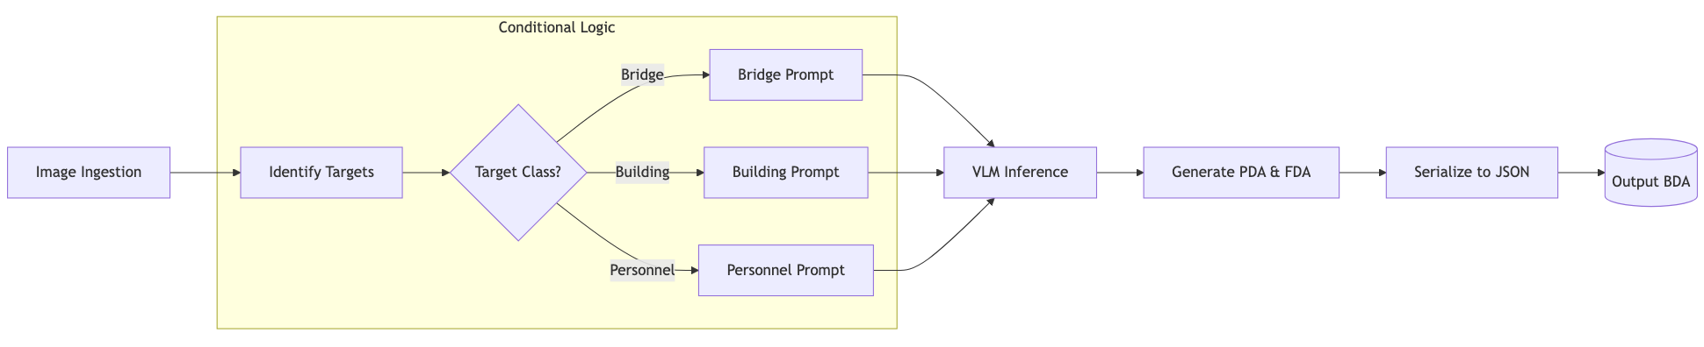
Figure 3: Workflow Diagram

6.0 DESIGN MODELS

This document includes two diagrams. The primary diagram (see Fig. 1) is the overall design architecture diagram, which depicts the end-to-end process for both operational use and experimental evaluation. In this diagram, post-strike imagery serves as the primary input and flows through preprocessing and model inference before producing a structured BDA output. The diagram also includes an evaluation path used in the experimental environment. In this path, model-generated BDAs are compared directly against each image’s analyst-provided reference assessment using an LLM evaluation framework. This allows consistent, scalable scoring of BDA outputs across multiple potential model architectures.

A support workflow diagram (see Fig. 3) is used to clarify the internal responsibilities of the system. This model separates vision components (e.g., VLM and optional object detectors), prompt logic (templates and rule constraints derived from doctrine), and report formatting. This separation reflects the design methodology and supports experimentation with different model configurations.

7.0 TEST DESIGN

Model testing is conducted using the collected evaluation dataset of 250 - 1000 post-strike images paired with analyst-provided reference BDAs. Each image is processed independently to generate a structured output as described in the data design section. Testing is performed across multiple model configurations, including a baseline VLM and extended architectures incorporating object detection. For each configuration, the same evaluation benchmark dataset and testing metrics are used to ensure reproducibility. Final testing is conducted in the DEVCOM ARL field environment to validate operational feasibility.

Model performance is quantified using the previously described LLM evaluation framework that compares model-generated BDAs to human-annotated references. The evaluation system focuses on the physical damage assessment performance as well as the functional damage assessment performance. For each target in the scene, the model’s physical damage assessment performance is calculated on a four point scale that is normalized between 0 and 1:

$S_{PDA}=\frac{1}{4N}\sum_{i=1}^{N}{}(T_{i}+D_{i}+C_{i}+L_{i})$
$Where:$
$T_{i}: Binary Target Type Identification$
$D_{i}: Binary Damage Category$
$C_{i}: Binary Confidence Level$
$L_{i}: Binary Logical Evidence$
$N: Number of Targets$

The model’s functional damage assessment performance is calculated on a two point scale that is also normalized between 0 and 1:

$S_{FDA}=\frac{F_{cat}+F_{log}}{2}$
$Where:$
$F_{cat}: Binary Functional Damage Category$
$F_{log}: Binary Logical Evidence$

The final score is normalized between zero and one using a hyperparameter that determines the significance of the physical damage assessment versus the functional damage assessment:

$S_{total}=αS_{PDA}+(1-α)S_{FDA}$
$Where:$
$α∈[0, 1]$

8.0 DEPLOYMENT MODEL

The system is designed for local, field-deployable execution with no reliance on external cloud services. The primary deployment strategy uses a containerized architecture to bundle the entire application into a single, portable image. This strategy ensures environment reproducibility, allowing the system to run on any Linux-compatible edge device without the need for external dependencies.

Operationally, the deployment environment utilizes host directories for data ingestion. The model utilizes local GPU acceleration, optimized for hardware with up to 64GB VRAM, to generate the BDA. The final product is structured as a JSON file and saved to the output directory, providing a full pipeline from raw sensor data to BDA output ready for analyst review.

9.0 RISKS / CHALLENGES

The primary risk is the lack of a supervised ground-truth dataset, as the project relies on manually curated labels derived from analyst interpretation of doctrine. Because no standardized benchmark exists, the labels are subject to human bias and inconsistency. To mitigate this, the plan of action involves a cross-validation review where a second analyst audits a subset of the imagery to ensure labeling consistency and objective alignment with doctrine.

Another risk involves environmental generalization, as the latent machine learning models were likely trained on clear imagery but must operate in degraded military settings. Factors such as adverse weather, varied terrain, or night vision conditions can pose challenges to model performance. The plan of action to address this is to gather sufficient testing data from a variety of degraded environments to validate model robustness.

Finally, the use of LLMs for automated evaluation introduces the risk of hallucinations, where the evaluator accepts the model’s logic for non-existing targets. To mitigate this, the plan of action is to provide the evaluator with human-labeled reference samples for every single scene to ground its assessment. If hallucinations persist, the system will pivot to VLM evaluations to allow the evaluator to directly see the imagery, accepting the increased computational cost to ensure scoring integrity.

10.0 TOOLS / DEPENDENCIES

This project uses Python due to its flexibility in implementing machine learning models, and based on the team’s overall experience. The system utilizes the uv package manager to maintain a high-performance, reproducible environment. The software stack is specifically selected for deployment on lightweight Linux-based edge operating systems such as Jetson Orin and is packaged into a Docker container. This containerization ensures that the entire environment–including Python (>=3.12), the Ollama inference engine (>=0.6.1), and CUDA 13.0 drivers–remains portable and stable.

The core machine learning pipeline relies on PyTorch (>=2.10.0) and Torchvision (>=0.25.0), alongside Transformers (>=5.0.0) and Accelerate (>=1.12.0) to manage model loading. These libraries were chosen to optimize memory efficiency, ensuring the system operates reliably within the 64GB VRAM hardware ceiling. Quality assurance is maintained through Ruff for doctrinal code formatting and Pytest for unit and integration testing.

11.0 TERMINOLOGY

CJCSI 3162.02a: Methodology for Combat Assessment – the doctrinal guide for this project.

BDA (Battle Damage Assessment): The timely and accurate estimate of damage resulting from the application of lethal and nonlethal military force.

PDA (Physical Damage Assessment): Quantifies physical damage to a target element, expressed as a combination of damage categories and confidence levels.

FDA (Functional Damage Assessment): Estimates the effect of target engagement on the target’s ability to perform its intended mission. Functional damage levels describe the effect on the target as a whole, based on cumulative damage at the target element level.

ARL: Army Research Laboratory.

DEVCOM: United States Army Combat Capabilities Development Command.

VLM: Vision-Language Model.

12.0 REFERENCES

[1] Joint Staff, Methodology for Combat Assessment, CJCSI 3162.02A, Washington, DC, USA, Jul. 16, 2021. Accessed: Jan. 25, 2026. [Online]. Available: https://www.jcs.mil/Portals/36/Documents/Library/Instructions/CJCSI%203162.02A.pdf

13.0 REFLECTION

A key lesson learned while developing this document was the importance of resisting the urge to introduce complexity too early. Initially, the team focused on rapidly integrating object detection and VLMs, but this approach lacked a clear way to determine whether added complexity actually improved BDA performance. Through continued discussion and review of doctrine, the team recognized that establishing a defensible evaluation framework and obtaining suitable data were prerequisite design decisions. By prioritizing doctrinal understanding, data design, and evaluation criteria first, the project established a foundation that allows future architectural complexity to be introduced incrementally and measured objectively. Without this evaluation-first approach, it would not be possible to determine whether more advanced designs provide meaningful value.

